(TOTAL HEALTHCARE SOLUTIONS PROVIDER)

P. O. Box GP 2821 Email: beautifulcreationsgh@yahoo.com
Accra - Ghana bcclgh@gmail.com
Tel 1: (233) 0302 667171 Website: www.bcmedicals.com
Tel 2: (233) 0302 677222 www.beautifulcreationsgh.com
Hotline: (233) 0244316616

Your Ref: Our Ref: Date: 19th February, 2026

SQ NO.: CR/SLCH/GD/001/25

ST. LUKE’S CATHOLIC HOSPITAL
P. O. BOX AP 5,
APAM
CENTRAL REGION

POWER OF ATTORNEY

TO WHOM IT MAY CONCERN

THIS POWER OF ATTORNEY IS TO AUTHORISE

MR. SAM D. ANSONG,
MANAGING DIRECTOR OF BEAUTIFUL CREATIONS COMPANY LIMITED

to sign the

SQ NO.: CR/SLCH/GD/001/25

FOR THE
PROCUREMENT OF NON-DRUG CONSUMABLES
and subsequently negotiate in event of award of contract.



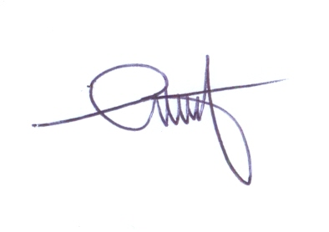
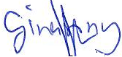

……………………………………. ……………………………………
DR. GEORGINA ANSONG (MRS.) SAM D. ANSONG
CFO MANAGING DIRECTOR

